Problem Solving and testing using Java

Week 5

Course code:10211CS227

NAME : V.NEELA DEVI

VTU:28598
Task 1:https://leetcode.com/problems/maximum-subarray/
Code:
class Solution {
public int maxSubArray(int[] nums) {
int currentSum = nums[0];
int maxSum = nums[0];

for (int i = 1; i < nums.length; i++) {
currentSum = Math.max(nums[i], currentSum + nums[i]);
maxSum = Math.max(maxSum, currentSum);
}

return maxSum;
}
}
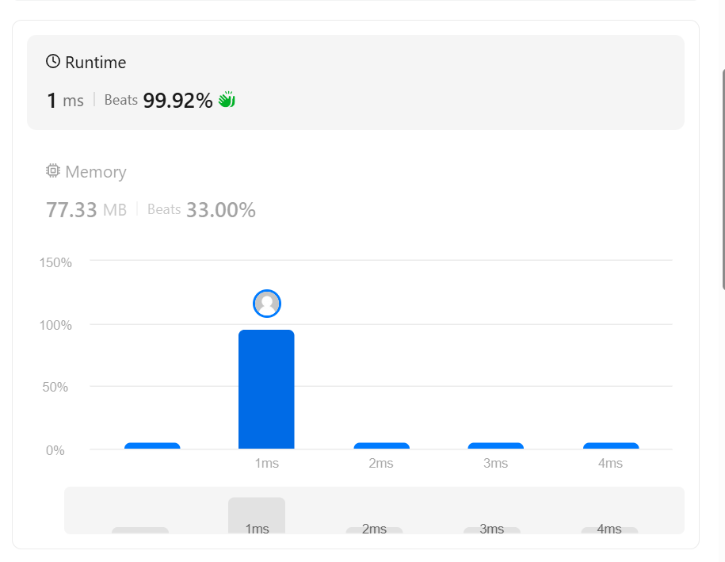
Task 2:https://www.hackerrank.com/challenges/the-birthday-bar/problem
Code:
import java.util.*;

public class Solution {

public static int birthday(List<Integer> s, int d, int m) {
int count = 0;

for (int i = 0; i <= s.size() - m; i++) {
int sum = 0;

for (int j = i; j < i + m; j++) {
sum += s.get(j);
}

if (sum == d) {
count++;
}
}

return count;
}

public static void main(String[] args) {
Scanner sc = new Scanner(System.in);

int n = sc.nextInt();

List<Integer> s = new ArrayList<>();

for (int i = 0; i < n; i++) {
s.add(sc.nextInt());
}

int d = sc.nextInt();
int m = sc.nextInt();

System.out.println(birthday(s, d, m));

sc.close();
}
}

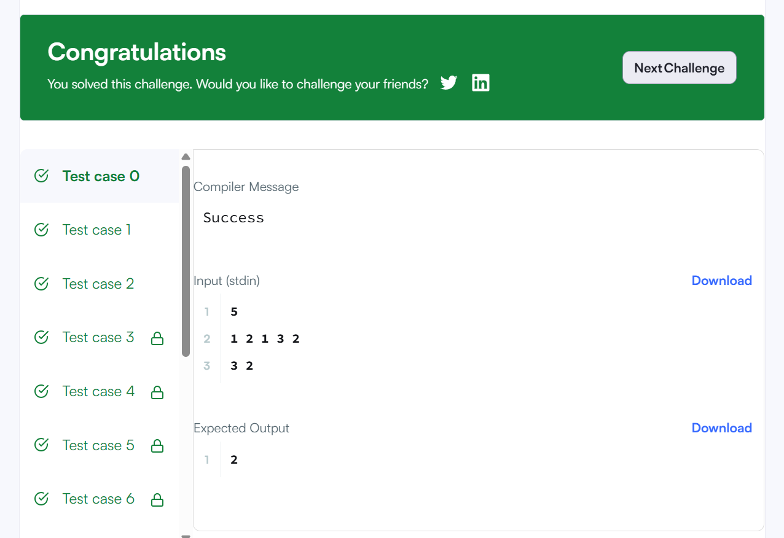

Task 3:https://www.hackerrank.com/challenges/maxsubarray/
Code :

import java.util.*;

public class Solution {

public static int[] maxSubarray(List<Integer> arr) {
int maxSubarray = arr.get(0);
int current = arr.get(0);

int maxSubsequence = arr.get(0);
int positiveSum = 0;

for (int i = 0; i < arr.size(); i++) {
int x = arr.get(i);

// Maximum subarray
if (i > 0) {
current = Math.max(x, current + x);
maxSubarray = Math.max(maxSubarray, current);
}

// Maximum subsequence
if (x > 0) {
positiveSum += x;
}

maxSubsequence = Math.max(maxSubsequence, x);
}

if (positiveSum > 0) {
maxSubsequence = positiveSum;
}

return new int[]{maxSubarray, maxSubsequence};
}

public static void main(String[] args) {
Scanner sc = new Scanner(System.in);

int t = sc.nextInt();

while (t-- > 0) {
int n = sc.nextInt();

List<Integer> arr = new ArrayList<>();

for (int i = 0; i < n; i++) {
arr.add(sc.nextInt());
}

int[] result = maxSubarray(arr);

System.out.println(result[0] + " " + result[1]);
}

sc.close();
}
}
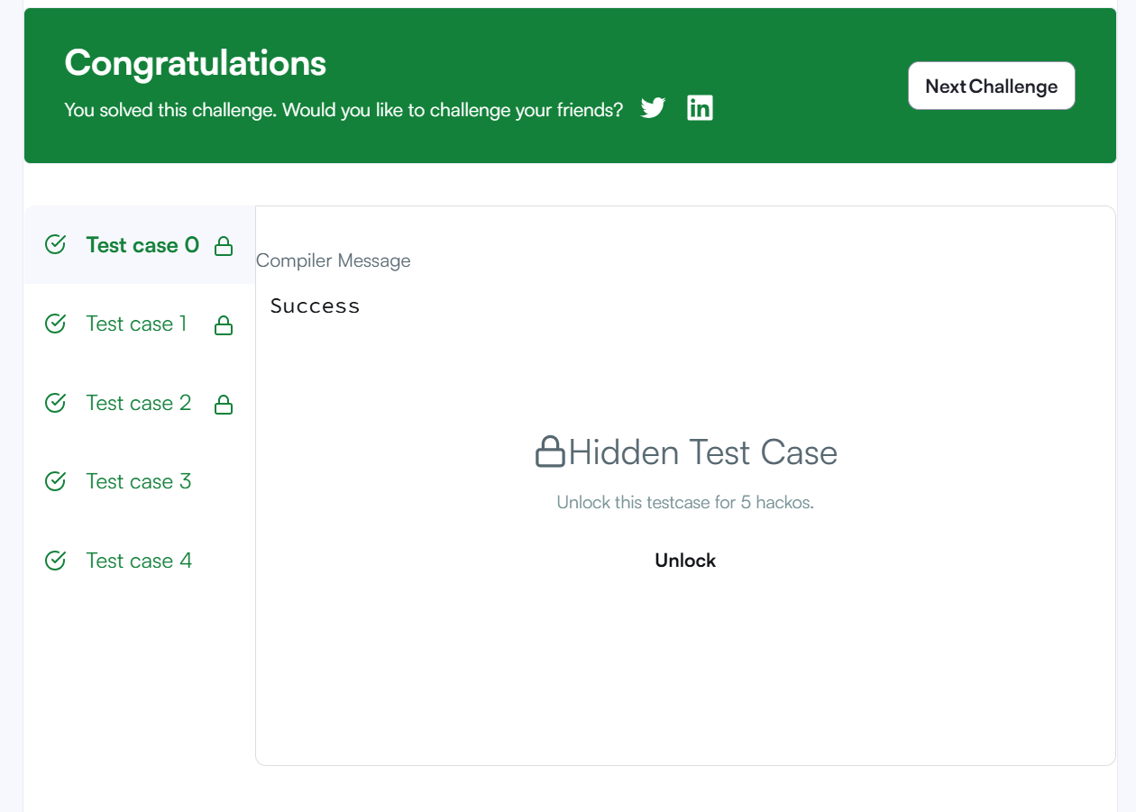
Task 4:https://leetcode.com/problems/maximum-sum-circular-subarray/
Code:
class Solution {
public int maxSubarraySumCircular(int[] nums) {
int total = 0;

int maxSum = nums[0];
int currentMax = nums[0];

int minSum = nums[0];
int currentMin = nums[0];

for (int i = 0; i < nums.length; i++) {
total += nums[i];

if (i > 0) {
currentMax = Math.max(nums[i], currentMax + nums[i]);
maxSum = Math.max(maxSum, currentMax);

currentMin = Math.min(nums[i], currentMin + nums[i]);
minSum = Math.min(minSum, currentMin);
}
}

// If all elements are negative
if (maxSum < 0) {
return maxSum;
}

// Maximum circular sum
return Math.max(maxSum, total - minSum);
}
}
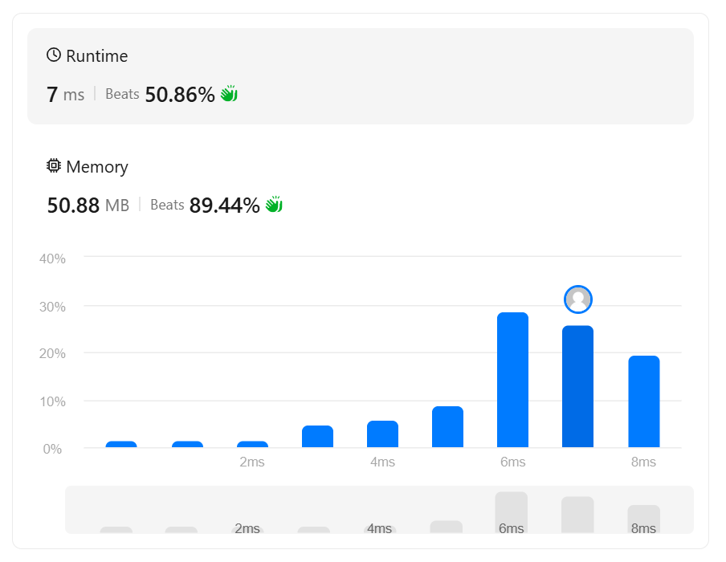
Task 5:https://leetcode.com/problems/string-to-integer-atoi/
Code:
class Solution {
public int myAtoi(String s) {
int i = 0;
int n = s.length();

// 1. Skip leading spaces
while (i < n && s.charAt(i) == ' ') {
i++;
}

// 2. Check sign
int sign = 1;

if (i < n && s.charAt(i) == '-') {
sign = -1;
i++;
} else if (i < n && s.charAt(i) == '+') {
i++;
}

// 3. Read digits
int result = 0;

while (i < n && Character.isDigit(s.charAt(i))) {
int digit = s.charAt(i) - '0';

// 4. Check overflow
if (result > (Integer.MAX_VALUE - digit) / 10) {
if (sign == 1) {
return Integer.MAX_VALUE;
} else {
return Integer.MIN_VALUE;
}
}

result = result * 10 + digit;
i++;
}

return result * sign;
}
}

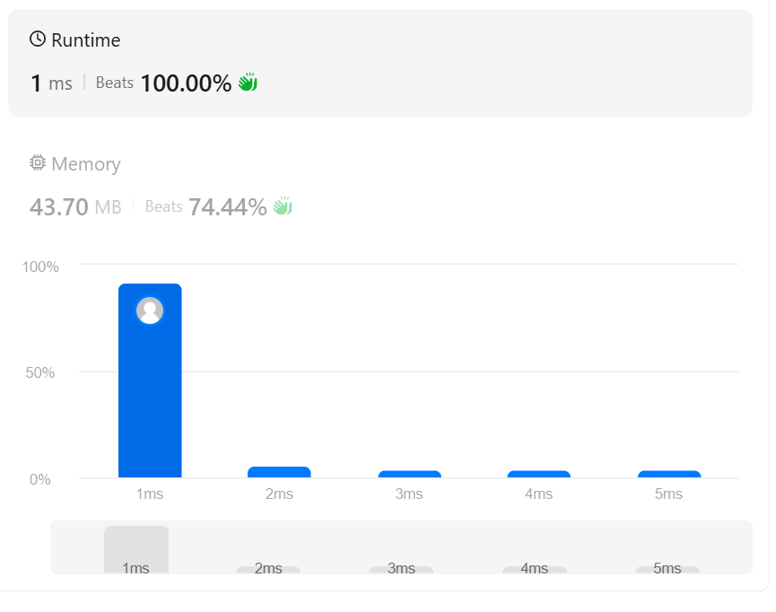
Task 6:https://www.hackerrank.com/challenges/alternating-characters/
Code:
import java.util.*;

public class Solution {

public static void main(String[] args) {

Scanner sc = new Scanner(System.in);

int t = sc.nextInt();

while (t-- > 0) {

String s = sc.next();

int count = 0;

for (int i = 1; i < s.length(); i++) {

if (s.charAt(i) == s.charAt(i - 1)) {
count++;
}
}

System.out.println(count);
}

sc.close();
}
}
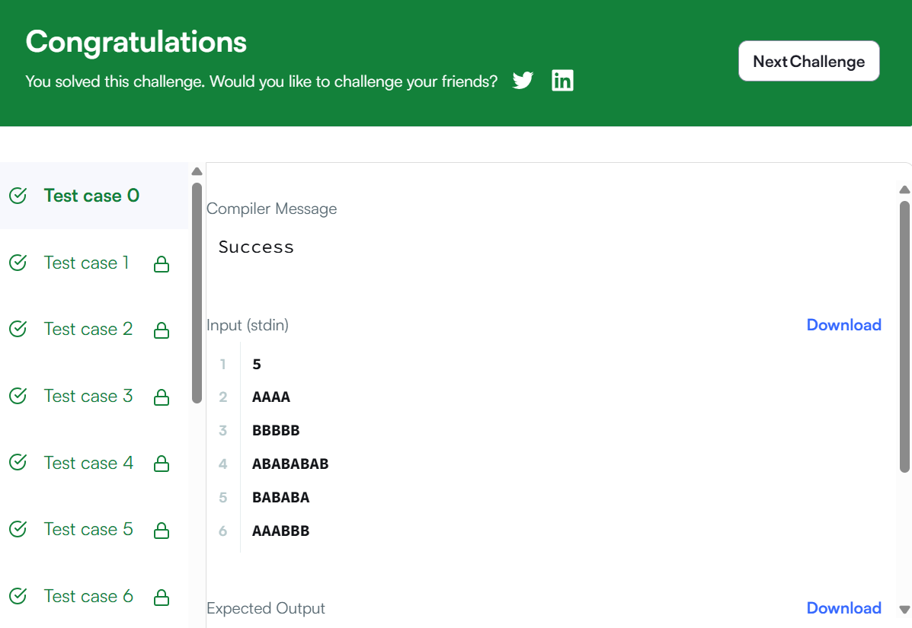
Task7:https://leetcode.com/problems/longest-substring-without-repeating-characters/
Code:
import java.util.*;

public class Solution {

public static int lengthOfLongestSubstring(String s) {
HashSet<Character> set = new HashSet<>();

int left = 0;
int maxLength = 0;

for (int right = 0; right < s.length(); right++) {

while (set.contains(s.charAt(right))) {
set.remove(s.charAt(left));
left++;
}

set.add(s.charAt(right));

maxLength = Math.max(maxLength, right - left + 1);
}

return maxLength;
}

public static void main(String[] args) {
Scanner sc = new Scanner(System.in);

String s = sc.nextLine();

System.out.println(lengthOfLongestSubstring(s));

sc.close();
}
}
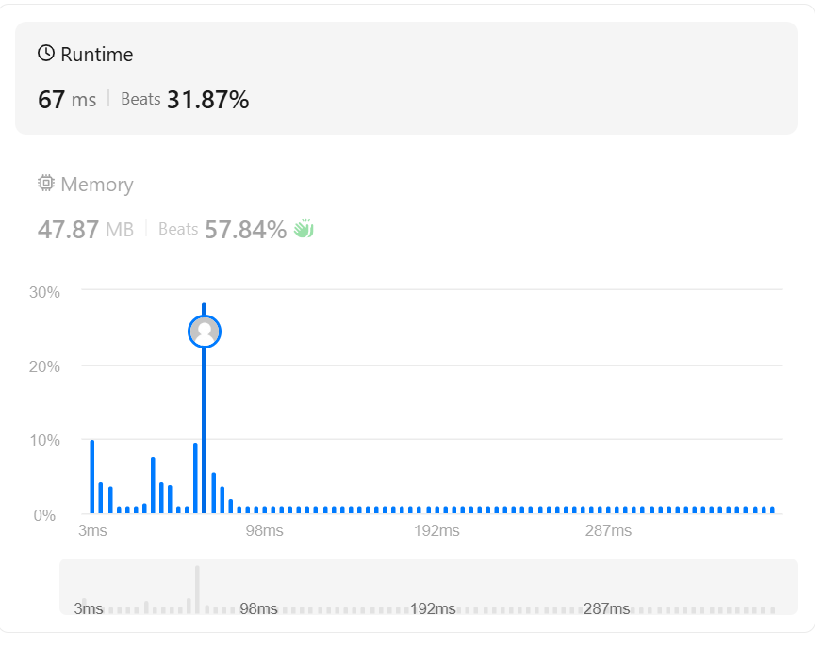
Task 8:https://leetcode.com/problems/find-and-replace-pattern/
Code:
import java.util.*;

public class Solution {

public static List<String> findAndReplacePattern(
String[] words, String pattern) {

List<String> result = new ArrayList<>();

for (String word : words) {
if (matches(word, pattern)) {
result.add(word);
}
}

return result;
}

public static boolean matches(String word, String pattern) {

int[] map1 = new int[26];
int[] map2 = new int[26];

Arrays.fill(map1, -1);
Arrays.fill(map2, -1);

for (int i = 0; i < word.length(); i++) {

int w = word.charAt(i) - 'a';
int p = pattern.charAt(i) - 'a';

// Check pattern -> word
if (map1[p] == -1 && map2[w] == -1) {
map1[p] = w;
map2[w] = p;
}
else if (map1[p] != w || map2[w] != p) {
return false;
}
}

return true;
}

public static void main(String[] args) {

Scanner sc = new Scanner(System.in);

int n = sc.nextInt();

String[] words = new String[n];

for (int i = 0; i < n; i++) {
words[i] = sc.next();
}

String pattern = sc.next();

List<String> result =
findAndReplacePattern(words, pattern);

for (String word : result) {
System.out.print(word + " ");
}

sc.close();
}
}
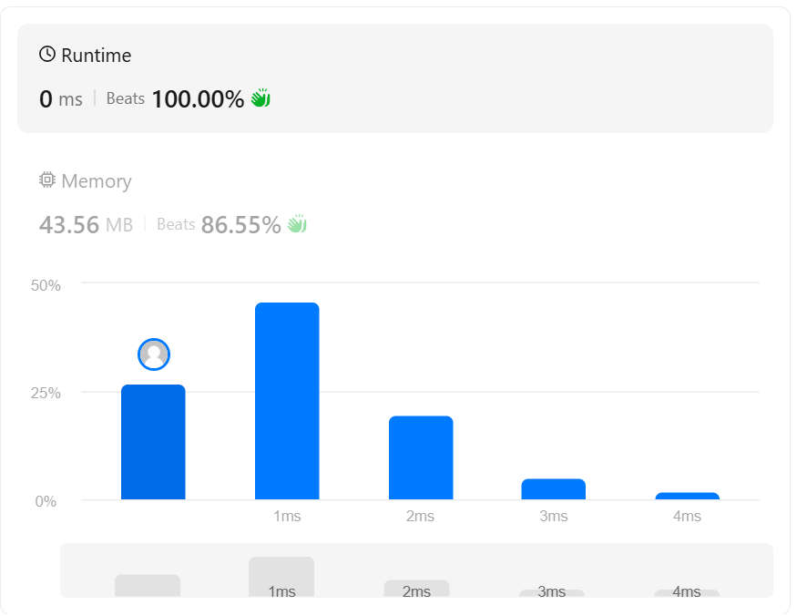

Task 9:https://leetcode.com/problems/string-matching-in-an-array/

Code:
import java.util.*;

public class Solution {

public static List<String> stringMatching(String[] words) {
List<String> result = new ArrayList<>();

for (int i = 0; i < words.length; i++) {

for (int j = 0; j < words.length; j++) {

if (i != j && words[j].contains(words[i])) {
result.add(words[i]);
break;
}
}
}

return result;
}

public static void main(String[] args) {
Scanner sc = new Scanner(System.in);

int n = sc.nextInt();

String[] words = new String[n];

for (int i = 0; i < n; i++) {
words[i] = sc.next();
}

List<String> result = stringMatching(words);

for (String word : result) {
System.out.print(word + " ");
}

sc.close();
}
}

